A CASE-STUDY BASED REPORT
ON
Explainable Cardiovascular Risk Prediction Using Machine Learning and SHAP: A Random Forest Case Study
submitted in partial fulfilment of the requirements for the Course
MACHINE LEARNING
BACHELOR OF TECHNOLOGY
in
A.Y.: 2026-27
by
Ayusha Das roll 2520039624
Under the Esteemed guidance of
Mr. Shaik Asif
Asst.Professor, Dept. of CSE




INDEX
Abstract 3
Introduction 3
Background 3
Motivation for the Project 3
Overview of the Work Carried Out 4
Scope and Responsible-Use Statement 4
Problem Statement 4
Case-Study Scenario 4
Central Case-Study Question 5
Formal Problem Definition 5
Objectives that Guide the Study 5
Assumptions and Limitations 5
Dataset and Exploratory Data Analysis 5
About the Dataset 5
Purpose of EDA 6
Preparation Steps Actually Performed 6
EDA Exploration - Implementation 6
Summary of EDA Findings 6
Algorithm Selection and Implementation 7

Conclusion 8

Signature of the Team members

Abstract
Predicting cardiovascular disease from routine health measurements is a well-studied problem, but most models return a label and nothing else. This case study walks through the whole workflow on the Kaggle Cardiovascular Disease Dataset, which holds 70,000 patient records: exploring the data, cleaning it, comparing four classifiers, and then looking inside the Random Forest model to see what drives its output.
Logistic Regression, Decision Tree, Random Forest and XGBoost were trained on an 80/20 train-test split. XGBoost scored highest with a test accuracy of 72.58%, followed closely by Logistic Regression (71.33%) and Random Forest (71.22%). Random Forest was still kept as the model to explain, because its feature importances and SHAP values can be read both across many patients and for a single patient. Age, blood pressure, BMI and weight came out among the features the model relies on most.
The project is an academic prototype built on a public dataset. Its explanations describe how the model behaves; they are not evidence of what causes heart disease, and the system is not meant for clinical decisions.

Introduction

Background
Cardiovascular disease is one of the leading causes of death worldwide, and spotting at-risk patients early helps doctors decide who needs closer follow-up. The information needed for this is already collected routinely: age, blood pressure, cholesterol, glucose levels, and a few lifestyle habits. That makes the problem a natural fit for supervised machine learning.
The difficulty is that accurate models are often opaque. If a system simply says "high risk", the person reading it has little basis for trusting or questioning that result. Recent work on explainable machine learning for cardiovascular risk, including a 2026 study in Frontiers in Artificial Intelligence by Paul and Syed Masood, addresses this by pairing prediction with interpretation methods such as SHAP. This project follows the same general idea, but carries out its own EDA, preprocessing, model comparison and explanation work on a public dataset.

Motivation for the Project
A prediction that nobody can question is hard to use in practice. Anyone working with patient data would want to know which measurements pushed a particular patient towards the "disease" class and by how much. We also wanted to see for ourselves that predictive accuracy and explainability are two different goals: the model that scores best is not automatically the one that is easiest to explain. Working through both on the same data was a practical way to learn the full machine learning pipeline instead of just training a single model.

Overview of the Work Carried Out
The work follows the sequence below, and each step is described in the sections that follow.
- Loaded the Kaggle dataset (70,000 records) and carried out exploratory data analysis.
- Cleaned the data: removed invalid blood-pressure records, converted age from days to years, added BMI and dropped the ID column.
- Split the cleaned data into 80% training and 20% testing sets.
- Trained and compared Logistic Regression, Decision Tree, Random Forest and XGBoost using test accuracy.
- Studied Random Forest feature importances to see which variables the model relies on.
- Used SHAP to explain the Random Forest model globally and for an individual patient.

Scope and Responsible-Use Statement
This is an academic case study, not a diagnostic tool. The data comes from a public source, the evaluation is limited to test accuracy, and no clinical validation has been done. Feature importance scores and SHAP values explain how the trained model behaves; they should not be read as proof that a given factor causes cardiovascular disease. Nothing in this report should be used to replace a doctor's judgement or to make medical decisions about real patients.

Problem Statement

Case-Study Scenario
Imagine a healthcare organisation that keeps historical patient records and wants to flag patients who may be at risk of cardiovascular disease. The staff who use the system need more than a yes/no prediction. For each patient they also want to understand the reasons behind the result, so they can judge whether it makes sense.
The system takes the following patient details as input:
- Age and gender
- Height and weight
- Systolic and diastolic blood pressure
- Cholesterol and glucose levels
- Smoking status, alcohol use and physical activity
And it is expected to produce:
- A cardiovascular disease prediction (0 = no disease, 1 = disease).
- The key factors that contributed to that prediction.

Central Case-Study Question
Can a machine learning model predict cardiovascular disease reliably from routine patient data, and can we show which patient attributes drive its predictions, both overall and for one individual patient?

Formal Problem Definition
Let the dataset be D = {(xᵢ, yᵢ)}, where each xᵢ is a vector of patient attributes (age, height, weight, blood pressure, cholesterol, glucose, smoking, alcohol use and activity) and yᵢ ∈ {0, 1} is the cardio label. The task has two parts. First, learn a classifier f that maps x to a predicted label and achieves the best possible accuracy on unseen test data. Second, for the chosen model, compute a contribution value for each feature that explains why f gave a particular output, both averaged over many patients and for one patient.

Objectives that Guide the Study
- Explore the dataset and find any data-quality problems before modelling.
- Prepare the data so that it is clean and suitable for training.
- Compare four classification algorithms on the same train-test split.
- Identify the features that the Random Forest model relies on most.
- Use SHAP to explain predictions for the whole test sample and for one patient.
- Present the workflow in a way that is easy for a non-expert to follow.

Assumptions and Limitations
We assume that the labels and measurements in the public dataset are accurate enough to learn from, and that a random 80/20 split gives a fair estimate of performance on new patients. Beyond that, the study has several limits that readers should keep in mind:
- It uses a single public dataset, with no independent external validation.
- Models are compared on test accuracy only; other metrics are left for future work.
- Extensive hyperparameter tuning and cross-validation were not carried out.
- Feature importance and SHAP describe the model's behaviour, not clinical causation.
- The work is a prototype and is not intended to support real medical decisions.

Dataset and Exploratory Data Analysis

About the Dataset
The study uses the Cardiovascular Disease Dataset from Kaggle. It contains 70,000 patient records spread over 13 original columns: an ID, age (stored in days), gender, height, weight, systolic and diastolic blood pressure (ap_hi and ap_lo), cholesterol, glucose, smoking, alcohol use, physical activity, and the target column cardio. In cardio, 0 means no cardiovascular disease and 1 means disease is present.
70,000  patient records | 13  original columns | 0  missing values | 0  duplicate rows

Figure 1: Basic properties of the dataset

Purpose of EDA
Before training anything, we wanted to know what the data actually looks like: how it is structured, whether it is complete, how the variables are distributed, and whether any values look wrong. What EDA turns up directly shapes the cleaning step, so skipping it risks training models on faulty data.

Preparation Steps Actually Performed
Based on what EDA showed, the following preparation steps were carried out:
- Invalid blood pressure removed. 29 records with zero or negative systolic or diastolic readings were dropped, leaving 69,971 records.
- Age converted. Age was originally stored in days, so it was converted into years, which is easier to read and interpret.
- BMI added. Body mass index was calculated from each patient's height and weight as a new feature.
- ID column dropped. It only identifies a row and carries no predictive information.
- Train-test split. The cleaned data was divided into 80% for training and 20% for testing.

EDA Exploration - Implementation
The exploration covered the following checks, each done on the dataset before any model was trained:
- Looked at the dataset structure and descriptive statistics for every column.
- Checked for missing values and duplicate rows.
- Examined how the target variable (cardio) is distributed.
- Studied the numerical features: age, height, weight and blood pressure.
- Studied the categorical features: gender, cholesterol, glucose, smoking, alcohol use and physical activity.
- Calculated BMI from height and weight.
- Ran a correlation analysis to see how features relate to each other and to the target.
- Inspected possible outliers, which brought up suspicious blood-pressure values.

Summary of EDA Findings
The dataset turned out to be structurally clean: no missing values and no duplicate rows across all 70,000 records. The main quality problem was in the blood-pressure columns, where a small number of impossible values (zero or negative readings) appeared. These were removed, along with the preparation steps listed above, before modelling began.

Algorithm Selection and Implementation
Four classifiers were chosen to cover a range from simple to more powerful. All were trained on the same training set and evaluated on the same held-out test set, so their accuracies can be compared directly.
Algorithm | Role in this study
Logistic Regression | A linear model used as a simple baseline for the prediction task.
Decision Tree | Predicts through a series of feature-based yes/no decisions; easy to follow but simple.
Random Forest | An ensemble of decision trees; used for prediction, feature importance and SHAP explanations.
XGBoost | A gradient-boosted tree model, included to see how a stronger method performs.

Table 1: Algorithms compared
Results. The test accuracies are shown below. XGBoost came out on top at 72.58%. Logistic Regression and Random Forest were almost level, separated by about 0.1 percentage points, while the single Decision Tree was clearly behind at 64.00%.
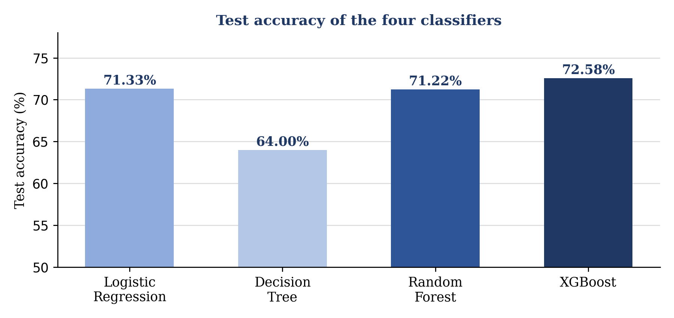
Figure 2: Test accuracy of the four models (vertical axis starts at 50%)
Key result
XGBoost reached the highest test accuracy (72.58%). The gaps among the top three models are small, which suggests that on this dataset the choice of algorithm matters less than the quality of the input data.

Why Random Forest was kept for explanation. Although XGBoost was slightly more accurate, Random Forest was retained as the main model for the explainability part. It gives built-in feature importance scores, works well with SHAP, and its accuracy is only about 1.4 percentage points lower. This keeps the two goals of the study separate: XGBoost shows what accuracy is achievable, while Random Forest shows how a model's reasoning can be examined.
Feature importance. Random Forest reports how much each variable contributes to its decisions. In this project age, systolic blood pressure (ap_hi), age in years (age_years), BMI, weight and diastolic blood pressure (ap_lo) were among the most important variables. Age appears twice because it is stored in both days and years, so the two entries describe the same underlying measurement. These scores describe what the model uses, not what causes disease; a feature can rank high simply because it is correlated with the outcome in this dataset.
SHAP explainability. SHAP (SHapley Additive exPlanations) was applied to the Random Forest model at two levels:
- Global explanation: shows how each feature contributes to the model's behaviour across the selected test patients.
- Patient-level explanation: a SHAP waterfall plot shows how each feature value pushes one specific patient's prediction higher or lower compared with the model's baseline.
Together these give a view that a plain accuracy figure cannot: not just whether the model is right, but what it is paying attention to when it makes a call.
Overall workflow.
1  Dataset | ▶ | 2  EDA | ▶ | 3  Data Cleaning | ▶ | 4  Feature Engineering

5  Train / Test Split | ▶ | 6  Model Training | ▶ | 7  Model Comparison | ▶ | 8  RF Feature Importance

9  SHAP Global | ▶ | 10  Patient-Level SHAP

Figure 3: End-to-end project workflow

Conclusion
This case study took a public cardiovascular dataset through a complete machine learning workflow. EDA showed that the data was complete but contained a few impossible blood-pressure values, which were removed before the data was split and used to train four models. XGBoost reached the highest test accuracy at 72.58%, and Random Forest was then used for feature-importance analysis and SHAP explanations, both overall and for an individual patient.
Key takeaway
Accuracy and interpretability are separate goals. A model that explains itself helps people question its predictions, provided the explanations are read as a description of the model and not as medical fact.

Possible next steps for the project include:
- More thorough hyperparameter tuning and cross-validation.
- Additional metrics such as precision, recall, F1-score, ROC-AUC and calibration.
- Testing the workflow on an independent external dataset.
- A simple interface where a user enters patient details and sees the prediction with its explanation.
- Checking whether the explanations stay stable across different models and patient subgroups.

Signature of the Team members
Ayusha Das (2520039624)

